ACFB | Adams County Farm Bureau Newsletter
April, May, June 2025 | Volume 8, Number2
In This Issue  - Spring Meeting  - Chicken BBQ  - ROD retires  - From the State  - Board of Directors  Brian Davis  President 717-528-4485  Debra Stock - Secretary /Treasurer- 717-624-2592  Sally Scholle First Vice -President 717-359-9472  Earl Stock Second Vice- President 717-476-5920  Brock Widerman 717-752-5402  Robert Niner 717-334-1937  Bob Clowney 717-334-7269  Frank Penning 717-465-8115  Gene Moose  717-334-5684  Amy Welker  717-580-0562  Suzanne Shea  717-321-6514  District 9 Director  Kevin Mountz  717-377-0297  ROD Ken Sechrist  717-409-9170  Calendar of Events  April  3 – Monthly Meeting  3- Spring Meeting  7 – FARMER Dinner  13 – Palm Sunday  13-19 – Rural Road Safety week  15- Income tax deadline  18- Good Friday  20- Easter  May  1 – Safety Contest entries due  1 – Monthly Meeting  2 PSU Trustee Election  14 – Mother’s Day  17 – Chicken BBQ  17 – Armed Forces Day  26 – Memorial Day  June  1 – Scholarship deadline  5 – Monthly Meeting  14 – Flag Day  15 – Father’s Day  22 -27  Service Provider  Quick Reference  Nationwide Insurance Providers  Pabody Insurance  Larry Blount  147 Carlisle St. Gettysburg  717-339-0055  Jillian A. Mylet Insurance  Jillian Struble  147 N. Fourth St.  Gettysburg  717-334-1161  Adamik Insurance Agency  5356 Baltimore Pike  Littlestown, PA. 17340  717-359-7380  PFB Health Services  1-800-522-2375  Check us out of Facebook  Visit our web page.  www.pfb.com/adams  Newsletter Editor  Deb Stock  359 Brickcrafter Rd  New Oxford, PA. 7350  717-624-2592  edstock1005@gmail.com  BE SAFE!  Farming is a profession of hope.  Brian Brett  The most wasted of all days is one without laughter.  The greatest mistake you can make is to be continually fearing that you’ll make one  Elbert Hubbard  Worry never robs tomorrow of its sorrow; it only sap today of its strength  A.J. Cronin  Kindness is one thing you can’t give away. It always comes back  George Skolsky  “You’ll have true happiness when you live to give, not to get.  Noa Shaw  Living is the art of getting used to what we didn’t expect  Eleanor Wood  Great opportunities to help others seldom come, but small ones surround us every day  Sally Koch  In the face of uncertainty, there is nothing wrong with hope.  Bernie Siegel  No day in which you learn something is a complete loss  David Eddings  Love doesn’t make the world go round. Love is what makes the ride worthwhile.  Franklin Jones  The most sincere compliment we can pay is…Attention .  Walter Anderson | Local News First!  Adams County Activity  Adams County’s  SAFEMARK DEALER  John J. Hess  200 Tall Oaks Road  Gettysburg, PA. 17325  717-334-8553  Local farmers working together  Welcome New Members: John Selter, Ben Mearns, Ivan Fisher, Tim Phlegar and Isaac Miller.  Spring Meeting  The Spring Meeting this year will be held at The Farmhouse Restaurant, 75 Cunningham Rd., Gettysburg, PA. 17325. On Thursday, April 3, 2025, starting at 6:00 pm. This is a buffet style dinner. Cost for the dinner will be $20.00 per person. RSVP to edstock1005@gmail.com or 717-476-5921 by March 27, 2025  All Farm Bureau members are encourgaged to attend.  Chicken BBQ  The Adams County FB schoalrship Committee is once again hosting a chicken BBQ to support the scholarship awarded to undergraduates studying in the field related to agricultue. This year the Arthur B. Musselmas will award a $2000.00 scholrship. The Chicken BBQ will be held on May 17, 2025 at the Ag Center starting at 11:00 until sold out. Cost will be $12.00  Our ROD, Kenny Sechrist, has announced his retirement as of March 31. Kenny will be greatly missed. He said he still plans to be somewhat active and plans to visit grandchildren and a new great grandchild in another state. We tuely appreciate all the hard work he has done for our region and for our county.  Scholarship  Applications are now being accepted for the Arthur B Musselman Scolarship. This year the award money has increased to $2000.00.  Applicants must be an Adams County resident at the time of the application, parents/guardian or the applicant must be a Adams County Farm Bureau member. Full-time, undergraduate student, enrolled or plan to be enrolled in a 4-year, 2-year, or technical school in the fields of agriculture or life science. Ex: (Agri-Business, Ag Engineer, Horticulture, Ag Mechanics, Forestry, Food Marketing) Applicant must submit a transcript, a letter of acceptance or proof of continuing education, and two letters of recommendation. Deadline for submitting the application is June 1, 2025. Applications can be found at PFB/Adams. com or contact secretary Debra Stock @ edstock1005@gmail.com  The monthly Board Meetings will be held April 3, following the Spring Meeting, May 1, and June 5, at the Ag Center, 670 Old Harrisburg Rd., Gettysburg, PA. 17325, starting at 7:30 pm.  WE are looking for a few good policies  One of the Farm Bureau’s most important activities is policy development. Members of each county Farm Bureau submit ideas and suggestions regarding issues that affect the farming community. These ideas are written as resolutions and voted on at the county annual meeting in November. Topics cover a wide range of ag issues including wetland management, wild game, commodities, animal health, vehicles, health and safety, taxes and water quality. If an issue involves agriculture in any way, it can be developed for policy.  After the county meeting, voting delegates from each county attend the state annual meeting and decide by majority vote which resolutions will be adopted as Pennsylvania Farm Bureau policy. While policies are not laws, they’re supported legislatively by the Farm Bureau at either the state or national level.  Ideas, issues and topics can be submitted at any time of the year via anyone on the county Farm Bureau board of directors or to policy chair Sally Scholle at 717-359-9472.  Renew Your Membership Now!  Reminder: If you have not renewed your membership already, now is the time to do it! Farm Bureau affects so many areas besides crop and livestock farmers. The policies that are passed and brought to the attention of the Pennsylvania legislators affect so many people from wineries, horse owners, to produce owners and sellers to commodity companies. If you know someone that isn’t but should be a member, ask them to join, the Farm Bureau is there to help all the agricultural community. You can renew your membership by mail or online at PFB.com  The Hunterstown Ruratins will be hosting their monthly breakfast at the Great Conewago Presbyterian Church at 174 Red Bridge Rd. The date is April 12. Breakfast runs from 7 – 10:30 a.m. and the cost is $9.00 for adults, $4.00 ages 5-12, under 5 is free. This helps support their scholarship program.  There is an opening for a Board Member. If you are interested in sitting on the Board, contact President Brian Davis at 717-528-4485.  Update on ACAP  The Agricultural Conservation Assistance Program (ACAP) originally brought nearly 3 million dollars to Adams County for the installation of soil and nutrient conservation best management practices. Those funds have almost been fully committed to projects. Due to the success of this funding, the state has continued to fund the program although at a much lower level. But Adams County is projected to receive north of $650,000 annually. The program was developed with minimal policy by the State Conservation Commission leaving it mostly to the Conservation Districts to develop policy locally. The district’s staff has been working with the Board of Director’s to address issues and concerns that have arisen as they navigate a new program.  Important topics being discussed include:  Improving the existing ranking form to help bring the highest priority projects to the top of the list.  Developing a schedule on accepting application. This will allow staff to collect applications and rank them against one another in an equitable fashion.  Developing policy on landowner/operator doing work and a mechanism to fairly compensate them for the work.  Developing policy that directs private sector engineering firms to evaluate least cost options and appropriate sizing of livestock related practices.  Evaluating practices to determine eligibility for funding. Are the practices or components of the practice necessary to address the resource concerns or are they more production related?  The Agricultural Committee of the Board of Directors will be tackling these topics and more at regularly scheduled meetings and bring their recommendations to the Board.  The ACAP program is very different from the forms of financial assistance the farm community have become accustomed to. Prevailing wage rules apply to projects over $25,000. Access to engineering staff from USDA NRCS is not an option for ACAP-only funded projects. Private sector engineering firms will most often be the only option for livestock related practices. It doesn’t necessarily compete with the USDA EQIP program, but each program has its pluses and minuses depending on the type of project being proposed. So, if you have some resource concerns, cropland erosion, large areas of dirt/mud in pasture, or manure storage needs contact the Conservation District office to discuss options.  Brian Sneeringer  Agricultural Conservation Technician  717-334-0636  From the State  . Secretary Redding Champions Agriculture in Budget Hearings  Over the course of two days, Pennsylvania Secretary of Agriculture Russell Redding testified before both the House and Senate Appropriations Committees, defending the agriculture budget and highlighting the critical investments needed to keep our industry strong. Facing hours of questioning, Secretary Redding made a compelling case for funding programs that support farmers, enhance food security, and drive agricultural innovation. His advocacy reinforces the essential role agriculture plays in Pennsylvania’s economy and the well-being of rural communities.  Key proposals in the budget include expanding the Agriculture Innovation Grant from $10 million to $25 million to meet high demand, increasing funding for the Pennsylvania Agricultural Surplus System (PASS) to better connect farmers with food banks, and maintaining strong support for animal health, biosecurity, and agricultural research. These investments not only help farmers but strengthen the broader state economy.  We appreciate Secretary Redding’s leadership in championing these priorities and encourage our members to reach out to their state officials to express support for these initiatives. Agriculture remains the backbone of Pennsylvania, and securing this funding will ensure its continued success.  - USDA Approves First Tranche of IRA Funding: On February 20, Secretary Rollins announced that USDA will release the first tranche of funding that was paused due to the review of funding in the Inflation Reduction Act (IRA). Per White House directives, Secretary Rollins will honor contracts that were already made directly to farmers. Specifically, USDA is releasing approximately $20 million in contracts for the Environmental Quality Incentive Program, the Conservation Stewardship Program, and the Agricultural Conservation Easement Program.  DAIRY  - Whole Milk for Healthy Kids Act Passed Out of Committee: On February 12, the House Education and Workforce Committee passed the Whole Milk for Healthy Kids Act out of committee with a vote of 24-10. This bill would allow for schools to offer the option of unflavored and flavored whole and two percent milk to students.  FARM BILL  - Status of Farm Bill: The 2018 Farm Bill expires September 30, 2025. No text has been introduced this Congress, but we can expect at least the House version to look similar compared to last year. Pennsylvania has 12 Members of Congress in our state who have never been through the farm bill process – Representatives Dean, Scanlon, Houlahan, Mackenzie, Bresnahan, Meuser, Lee, Joyce, Reschenthaler, and Deluzio as well as Senators McCormick and Fetterman. This means a lot of education and advocacy efforts are needed. Please reach out to Bailey Fisher with any intel you gather from meetings with your federal legislators about farm bill.    Go to pfbfriends.com/donate to help Raise the Barn!    

Do you have a Business?

Would you like to advertise in the Newsletter?

The Adams County Farm Bureau would love for you to advertise in their newsletter. A full page ad cost $100.00, half page ad cost $60.00, and a quarter page cost $40.00 per newsletter.
Your ad will be seen by all Adams County Farm Bureau Members. Contact Deb Stock at edstock1005@gmail.com

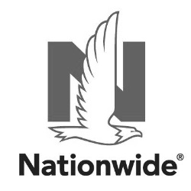 Nationwide is on your side. Visit a Nationwide Agent today!

Jillian Mylet Insurance
Jillian Struble
147 N. Fourth St, Gettysburg, PA 17325
- 717.334.1161
- mylet@nationwide.com

Pabody Insurance
Larry Blount
147 Carlisle St., Gettysburg, PA 17325
- 717.339.0055

John Adamik Insurance Agency
5356 Baltimore Pike
Littlestown, PA. 17340
717-359-7380

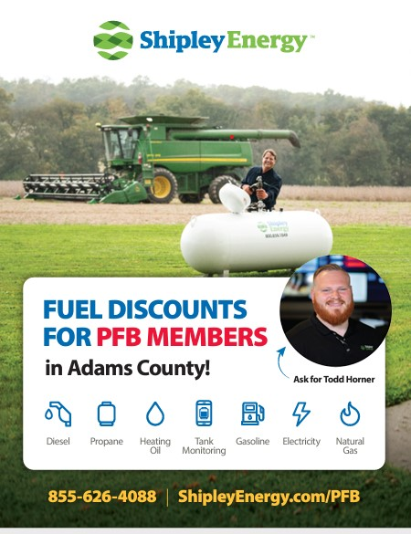
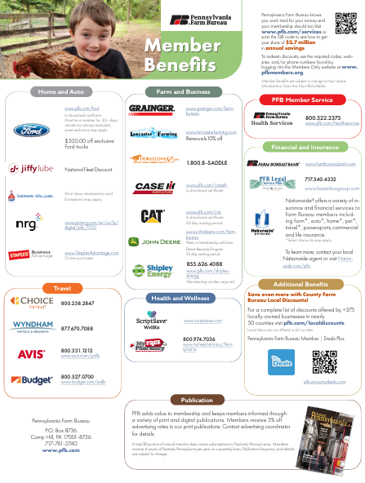




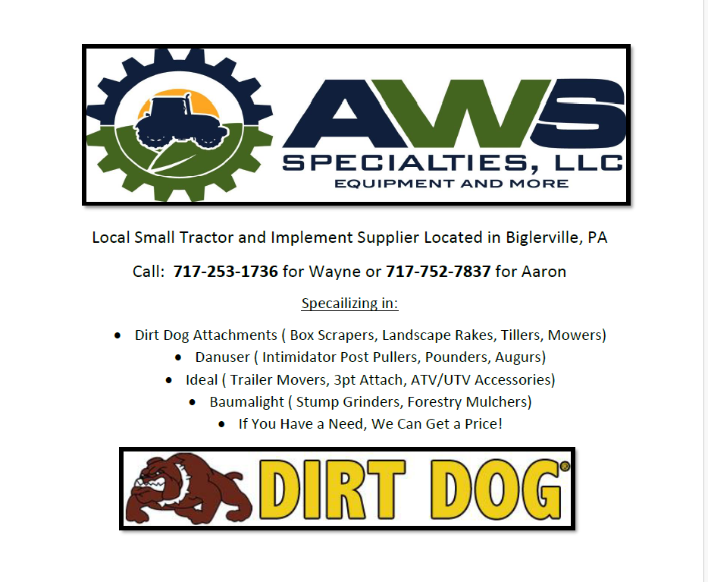

Adams County Farm Bureau Presorted Standard.
359 Brickcrafter Rd. U.S. Postage
New Oxford, PA. 17350 Mercersburg,PA 17236
Paid

Permit # 15

